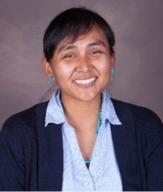

Dr. Erelda Gene is a tribal member of the Dine’ People from Blue Gap, AZ. She is the second oldest of four siblings that grew up on the Navajo Reservation and graduated from Winslow High School. She obtained her B.S. in Public Health from Northern Arizona University in 2012 and her O.D. from the Massachusetts College of Pharmacy and Health Sciences from Worcester, MA in 2017. She then graduated from the Primary Care Residency Program in Tahlequah, OK. In 2018, she started as a clinical optometrist at Zuni Comprehensive Health Care Center in Zuni, NM. In 2020, she was appointed the Acting Chief of Optometry. When the pandemic hit the community, Dr. Gene co-coordinated operations of labor pool, COVID-19 testing events, and vaccination clinics in addition to her clinical and acting chief duties. Dr. Gene is the Logistics Coordinator for the hospital’s command team. Lastly, she is also the co-founder of the Health Occupation Student Association, which assists local high school students to pursue careers in health care. Her drive stems from her experience of living in a rural area where health care continues to be a disparity- which is true amongst all Native American population.

